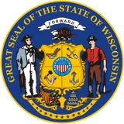
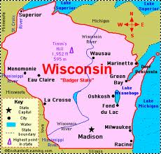
Wisconsin Facts
Grade 4

Key the facts below to practice your keyboarding skills. Use the word bank below to replace the line.

The State _______________ is the Mourning Dove. With a gentle "coo" and a graceful flap of its wings, the mourning dove flew over the state as the official symbol of peace in 1971

The State _____________ is Red Granite. Chosen for its economic importance in the state in 1971, the speckled igneous rock is composed of quartz and feldspar.

The State _____________ is Milk. The perfect complement to cookies, "America's Dairyland" chose to make milk the official beverage of the state to echo its abundant dairy heritage in 1987.

The State _______________ is Corn. Used for everything from livestock feed, to ethanol fuel, to the cornerstone of a delectable summer barbecue, corn was made the official state grain in 1989 to bring attention to its many uses.

The State ____________ is the Sugar Maple. With its bright yellow fall colors, and its delectable spring harvest of sweet maple sugar, the sugar maple became the state's official tree in 1949.

The State ________________is "On Wisconsin!" The rhythmic and rousing beats of "On Wisconsin," already a popular football song since 1909, began filling the air as the official state song in 1959.

Word Bank

Song Symbol of Peace Grain
Beverage Rock Tree
Motto

